Application Report: 4Cast
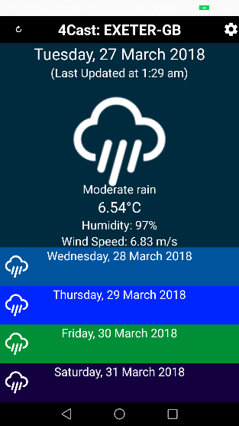
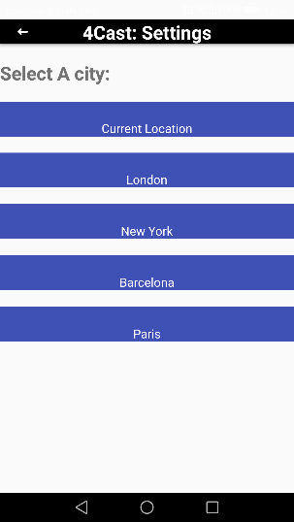
1. High level overview of the application
The application displays the weather information for today as well as the next four days after that in the form of series of horizontal bars filling the width of the screen one after the other. Detailed information for today is shown in the expanded view of it, when the user clicks on one of the other days, that day becomes the selected day and shows more of its details (see right).
The user can also change the location in the settings page to one of 5 pre-set locations, which will lead to the app redirecting to the home page and displaying this information. In the case that the app is offline, the most recent weather data for the most recently viewed location is shown.

1.1. Additional features added
In addition to the app’s core functionality, several additional features are added for the usability and professionalism of the app:
- When the app is being used during the day, it has a brighter colour scheme and the sunshine icon for a clear forecast.
- When the app is being used during the night- it has a darker colour scheme and the moon icon is used for a clear forecast
- A refresh button is included to get the most recent weather updates
- If connection is lost, when attempting to refresh the page, the title will be greyed out and a toast will pop up to notify you that there is no connection
- If the user tries to change the location with no connection, the app will notify the user that there is no connection and that new data cannot be obtained
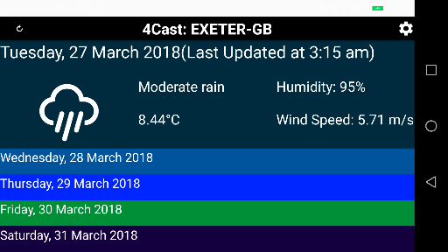
- When the screen rotates, the layout of the main page changes in order to fit in all of the data
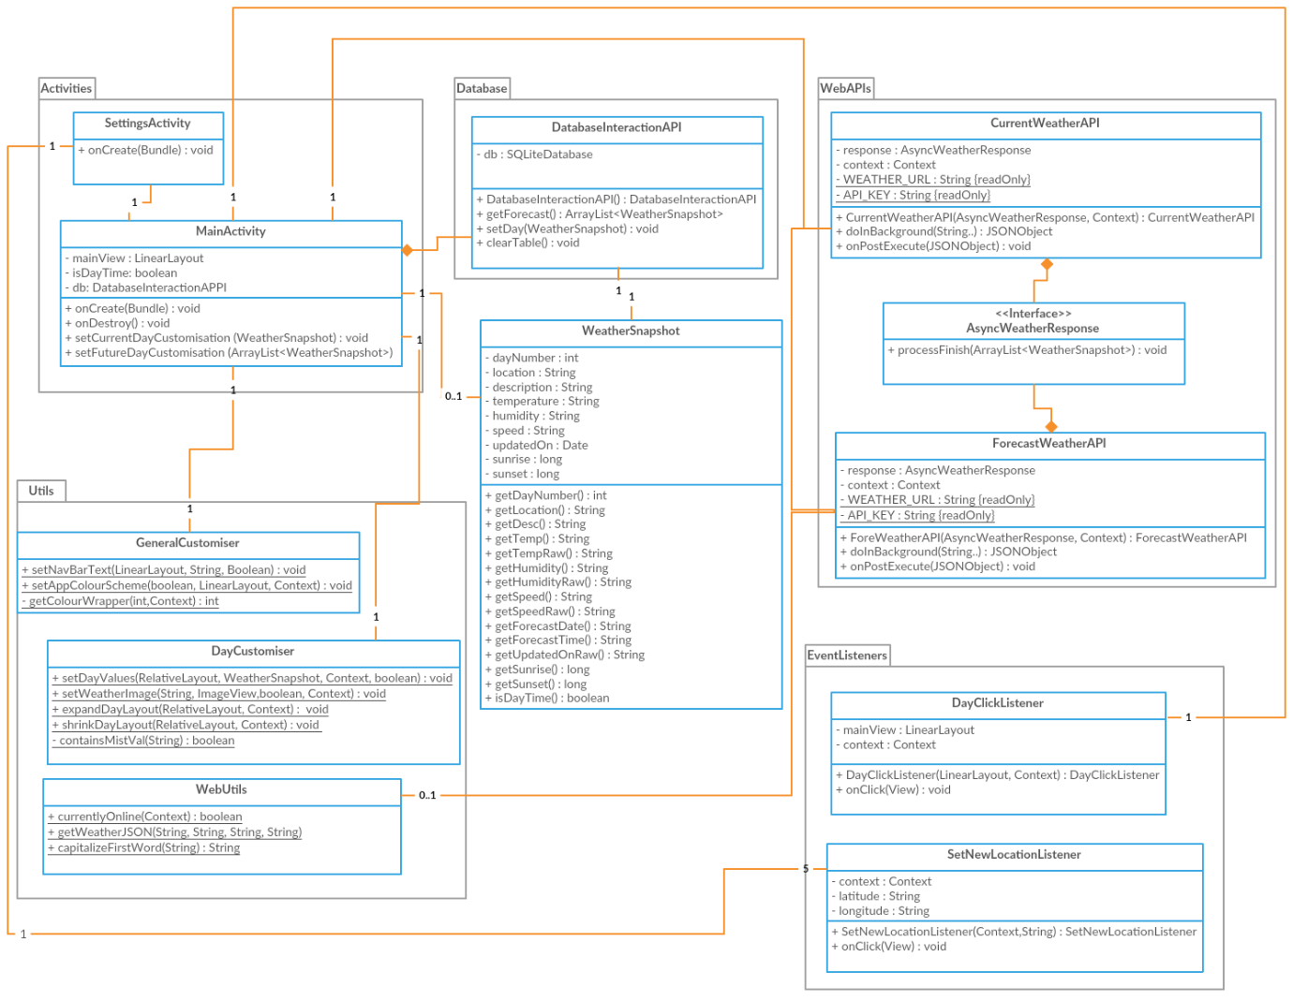
2. UML Diagram

3. Breakdown of java objects in diagram and functionality of app
3.1. Activities
These are the Activity classes for UI interaction in my application; both extending the AppCompactActivity class.
3.1.1. Main
This is the main activity, the first one that is launched when the application is started. My implementation of the onCreate() Method calls the various web APIs (see below) in order to get the weather data for the 5 days in the forecast, before rendering them in the UI and attaching event listeners to the various buttons that are present on the screen.
3.1.2. Settings
This activity displays the settings for changing the app location. It attaches event listeners to each of the location options on the screen, enabling the location preference to be changed by clicking on them.

3.2. Event listeners
These listeners are responsible for the user interaction and navigation of the app. The first 2 listeners are key to the app’s functionality, hence why they were implemented as classes inside the EventListeners folder.
3.2.1. DayClickListener
Implements View.onClickListener. This is set by the main activity to facilitate the clicking of a day that currently isn’t active. When triggered, the event expands the size and detail of the selected day and shrinks the others using DayCustomiser (see below). After this, it reassigns the event listeners so the selected day doesn’t respond to a click while the remaining 4 day views respond to the same listener.
3.2.2. SetNewLocationListener
Also implements View.onClickListener. This listener is set by the settings activity to facilitate the clicking of a location option in the settings menu. When this occurs, the listener saves the latitude and longitude of the chosen city in the app’s shared preferences. After this, the listener uses an intent to navigate back to the activity where the onCreate() method will be called again, leading to the loading of new data using the new latitude and longitude.
3.2.3. Navigation listeners
These listeners facilitate the simple navigation between the main activity and the settings activity. By clicking the settings button in the top right hand corner of the main menu, an intent is created that starts the settings activity. To return to the main menu, clicking the back button in the top left corner of the settings menu triggers the finish() method, causing the activity stack to navigate back and resume the main activity.
3.2.4. Refresh listener
By clicking the refresh button in the top left hand corner of the app, this listener checks to see if the phone is connected to the internet. If it is connected, the activity is restarted using an intent leading to the onCreate() method repopulating the menu with the most recent weather data. If the device is not connected, then the app does not refresh as this would be a waste of time due to the exact same information being reloaded from the database.
3.3 WeatherSnapshot
This is the object that represents all of the forecast data for a specific day. It has values indicating what day it is and weather data such as a summary of the weather, the temperature, wind-speed and humidity. This information is accessed by the customisation classes in order to populate the fields of the main activity with the relevant data. The object is well encapsulated, meaning all of the object’s values are private and accessed by methods. Some of these methods return a certain value in a raw format for use with the DatabaseInteractionAPI; while other methods return the same field but in a format modified for display. An example of this is adding “°C” at the end of the temperature field.
3.4. WebAPIs
These are the API classes that interact with the OpenWeatherMap server in order to parse the forecast information into WeatherSnapshot objects. Both of these APIs implement the AsyncTask object in order to remove the potentially long internet based computation from the UI thread. The classes have private fields corresponding to the URL and API-key which is why they are separate classes and not inheriting from a common interface.

3.4.1. CurrentWeatherAPI
This API obtains the JSON values for the current weather API service and converts them into a single WeatherSnapshot object. The values returned are the most recent update on the current weather, including today’s sunrise and sunset. These 2 values are only obtained for the current day by this API and are used to determine whether it is currently night or day in order to edit the design of the app.
3.4.2. ForecastWeatherAPI
This API obtains the JSON values for the forecast5 API service and converts them into the remaining 4 days. The forecast for these days happens every 3 hours but since we only need one WeatherSnapshot, the 3 hour time slot that is closest to the current time is selected. In a similar fashion to the CurrentWeatherAPI, The 4 days are parsed into WeatherSnapshot objects containing the relevant data before storing these snapshots in the database and then rendering them into the main view.
3.4.3. AsyncWeatherResponse
This is an interface which is present in each of the API classes as a field. It has a processFinish() method that is only implemented inside the constructor of the APIs inside the main activity. This means it can access the fields and methods of the main class without having to have the information passed to it. The processFinish() method is called right at the end of the onPostFinish() method in the APIs.
3.5. Utils
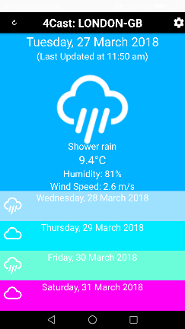
These are all classes with static methods that are used to aid the computation of other parts of the application.
3.5.1. GeneralCustomiser
This class contains static methods that customise the total layout of the app’s main view. It is responsible for changing the navigation bar’s text, making it relevant to the current location. It also sets the colour scheme of the application by establishing whether it is currently daytime or night time by looking through the information given by the WeatherSnapshot. Once this is established, the colour scheme is set with the elements of the main menu having lighter colours in the day and darker colours in the night.
3.5.2. DayCustomiser
This class contains static methods that customise a specific day entry in the view. These methods render the day’s information in the view as well as containing the methods for expanding and shrinking each day section as specified in the DayClickListener event handler.
3.5.3. WebUtils
These static methods are concerned with the web side of the application. One of its methods checks if there is an internet connection or not. This affects various parts of the app such as how the event listeners respond as well as getting information from the database if there is no connection. The class also provides the method to establish a HTTP connection with the OpenWeatherMap API server which gets the JSON data to be rendered by the web APIs.
3.6. DatabaseInteractionAPI
This class interacts with a SQLite database containing a single table used for storing the most recent weather details in the case that the phone loses its connection. When the WeatherSnapshot objects are first created by the Web APIs, each bit of information for each day is stored in the database; meaning when needed, the 5 days can be directly recreated by getting this information from the database.

